## Q1 Preponed Departure Date

Due to some reason, the onboarding flights are preponed for five days other than the flights that are not departing from 'Miami'.

Write a query to display the booking id, flight_name and preponed date. Give an alias name to the preponed date as 'PREPONED_DEPARTURE_DATE'.

Sort the results based on the booking id in descending order.

**SAMPLE DATA:**

**Booking_id flight_name         flight_source         flight_date**

B1                 United Airlines Denver         2019-07-05

B2         Kingfisher Airlines Miami         2019-08-04

B3         Qatar Airways San Antonio 2019-03-21

**SAMPLE OUTPUT:**

**Booking_id flight_name         PREPONED_DEPARTURE_DATE**

B1         United Airlines 2019-06-30

B3         Qatar Airways         2019-11-26

---------------------------------------

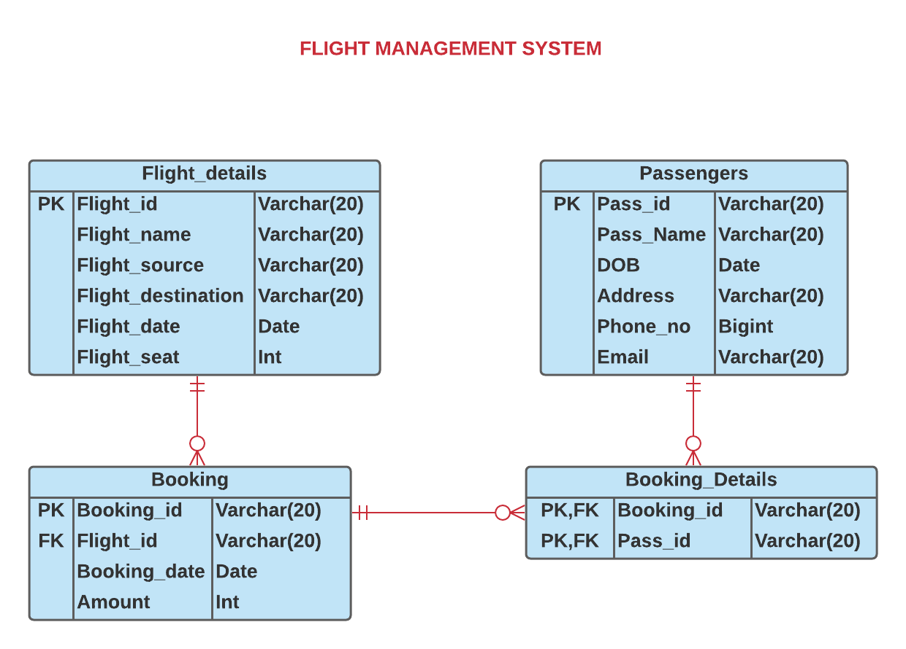

## Q2 **Customer Purchase Details**

Write a query to display the customer id, customer name, phone number, and purchase date of all the pets purchased by customers other than 'Delhi' city.

Sort the records based on the customer id in descending order.

(Hint: Data is case sensitive.)

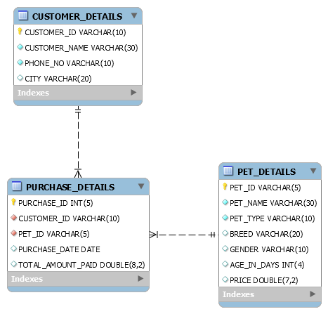

## Q3 **Customer With Email**

Write a query to display the customer name, order id, and order date of customers only with 'gmail' account.  
Sort the records based on the order id in descending order.

(Hint: Data is case-sensitive.)

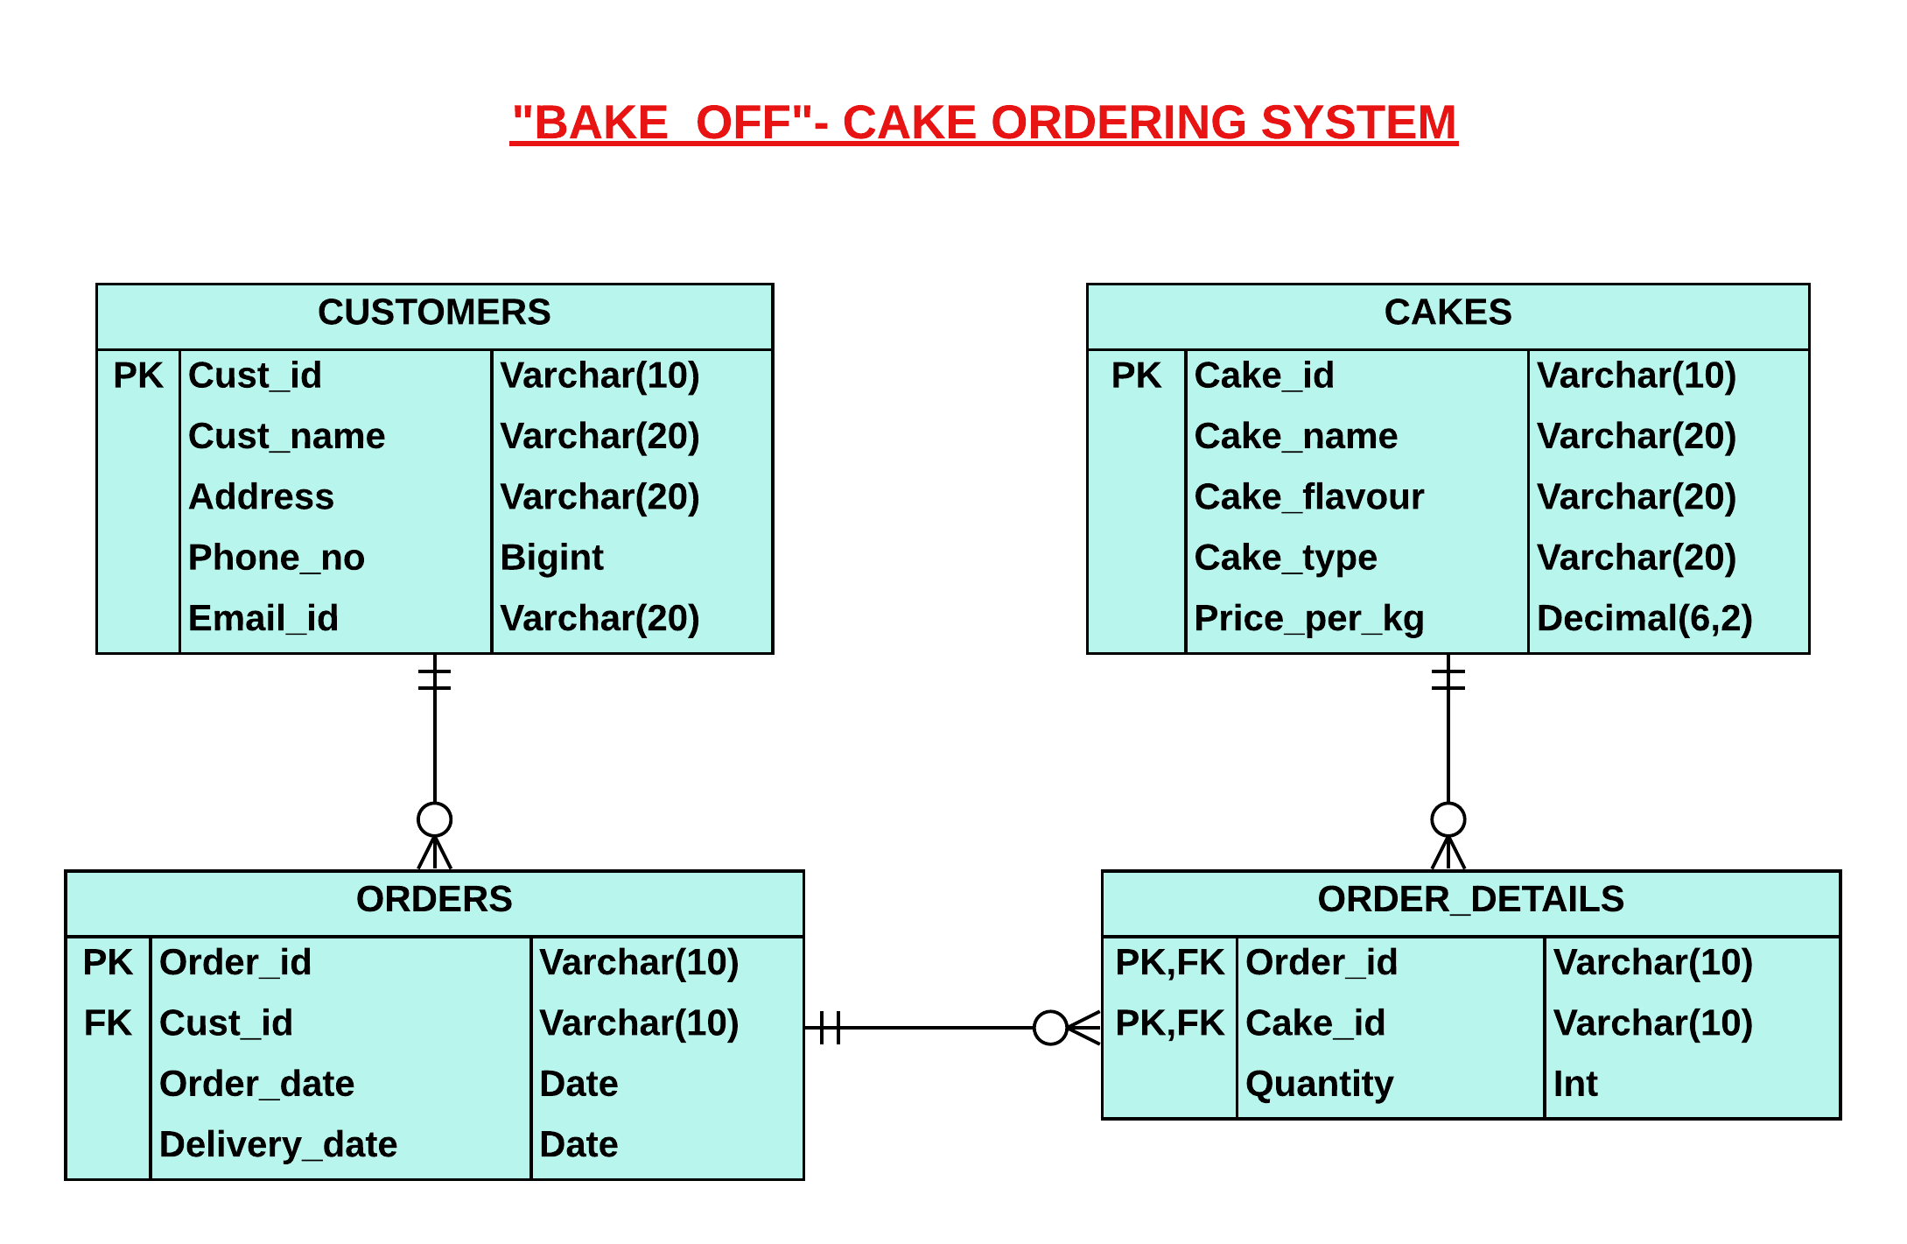

## Q4 **Boat With Same Capacity**

Write a query to display the Id and name of all the boats with the same seating capacity.

Sort the results based on the boat name in ascending order.

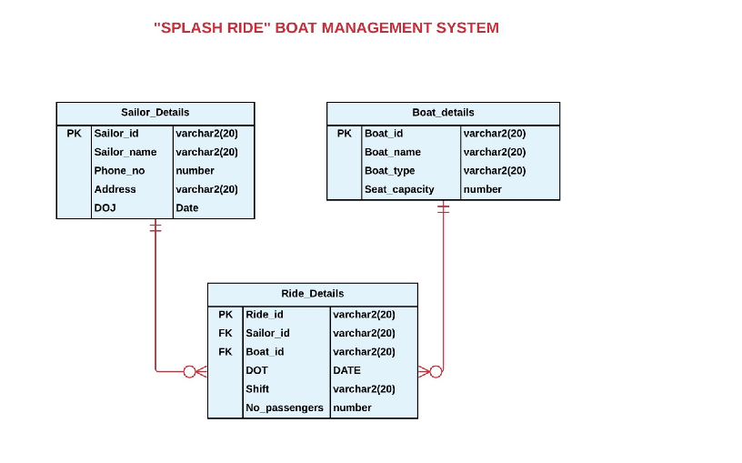

## Q5 **Product Category Details**

Write a query to display the unique product name and category of all products with a rating of less than 3.

Sort the results based on the product name in ascending order.

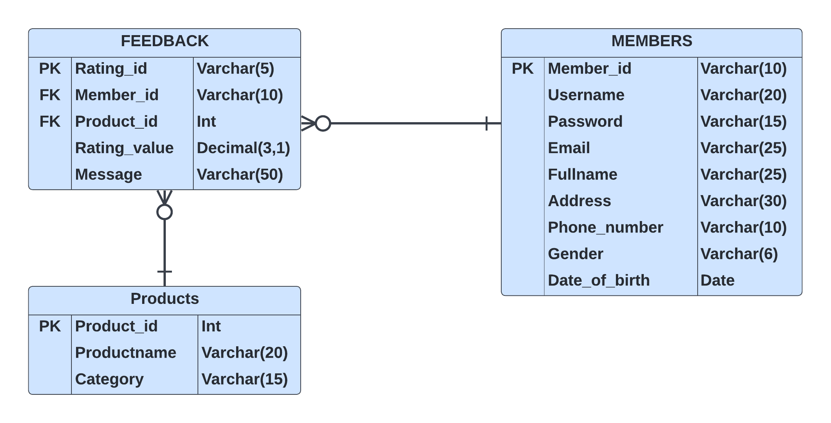

## Q6 **Member and product details**

Write a query to display the full name, email, member id and product id of all the members who were born in first and last month of the year.

Sort the records based on the full name in descending order.



## Q7 **Date Of Delivery**

Write a query to display the customer name, email id and address of all the customers whose cakes are not delivered on the ordered date. If the address is not available, then display the phone number. Give an alias name as 'Contact_Info' for the address of the customer.

Sort the results based on the customer name in ascending order.



## Q8 **Movie And Theatre Details**

Write a query to display the movie name, theatre id and duration of all the screened movies other than 'Hindi' language movies.

Sort the records based on the movie name in descending order.

(note: language can be in any case like: 'Hindi', 'hindi', 'HINDI')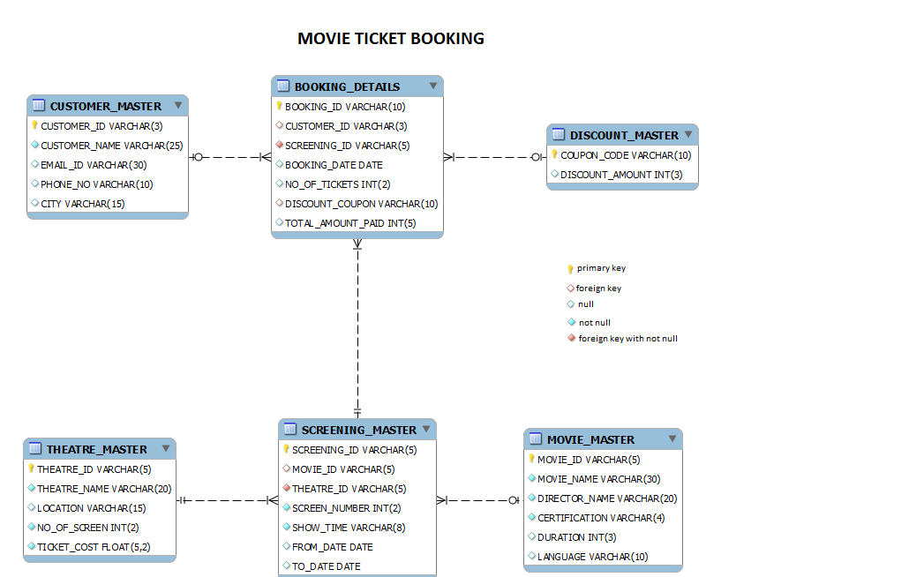

## Q9 **Chicago Flights**

Write a query to display the name and source of all the flights that arrive in the same city,if and only if the flight doesn't arrive in 'Chicago'.

Sort the results based on the destination in ascending order and the name in ascending order.

(Note:Data is case sensitive.)



## Q10 **Member Details Based On Condition**

Write a query to display the full name of all the members with Gmail accounts who are from "Bangalore", if and only if the rating is greater than 4.

Sort the records based on the full name in descending order.

(**Hint:** Data is case sensitive)



## Q11 **Specific Patient Address**

Write a query to display the first name of the patient, appointment reason, appointment time and bill amount of patients whose address contains 'Avenue' in it.

Sort the results based on the appointment time in ascending order.

(**Hint:** Data is case sensitive.)

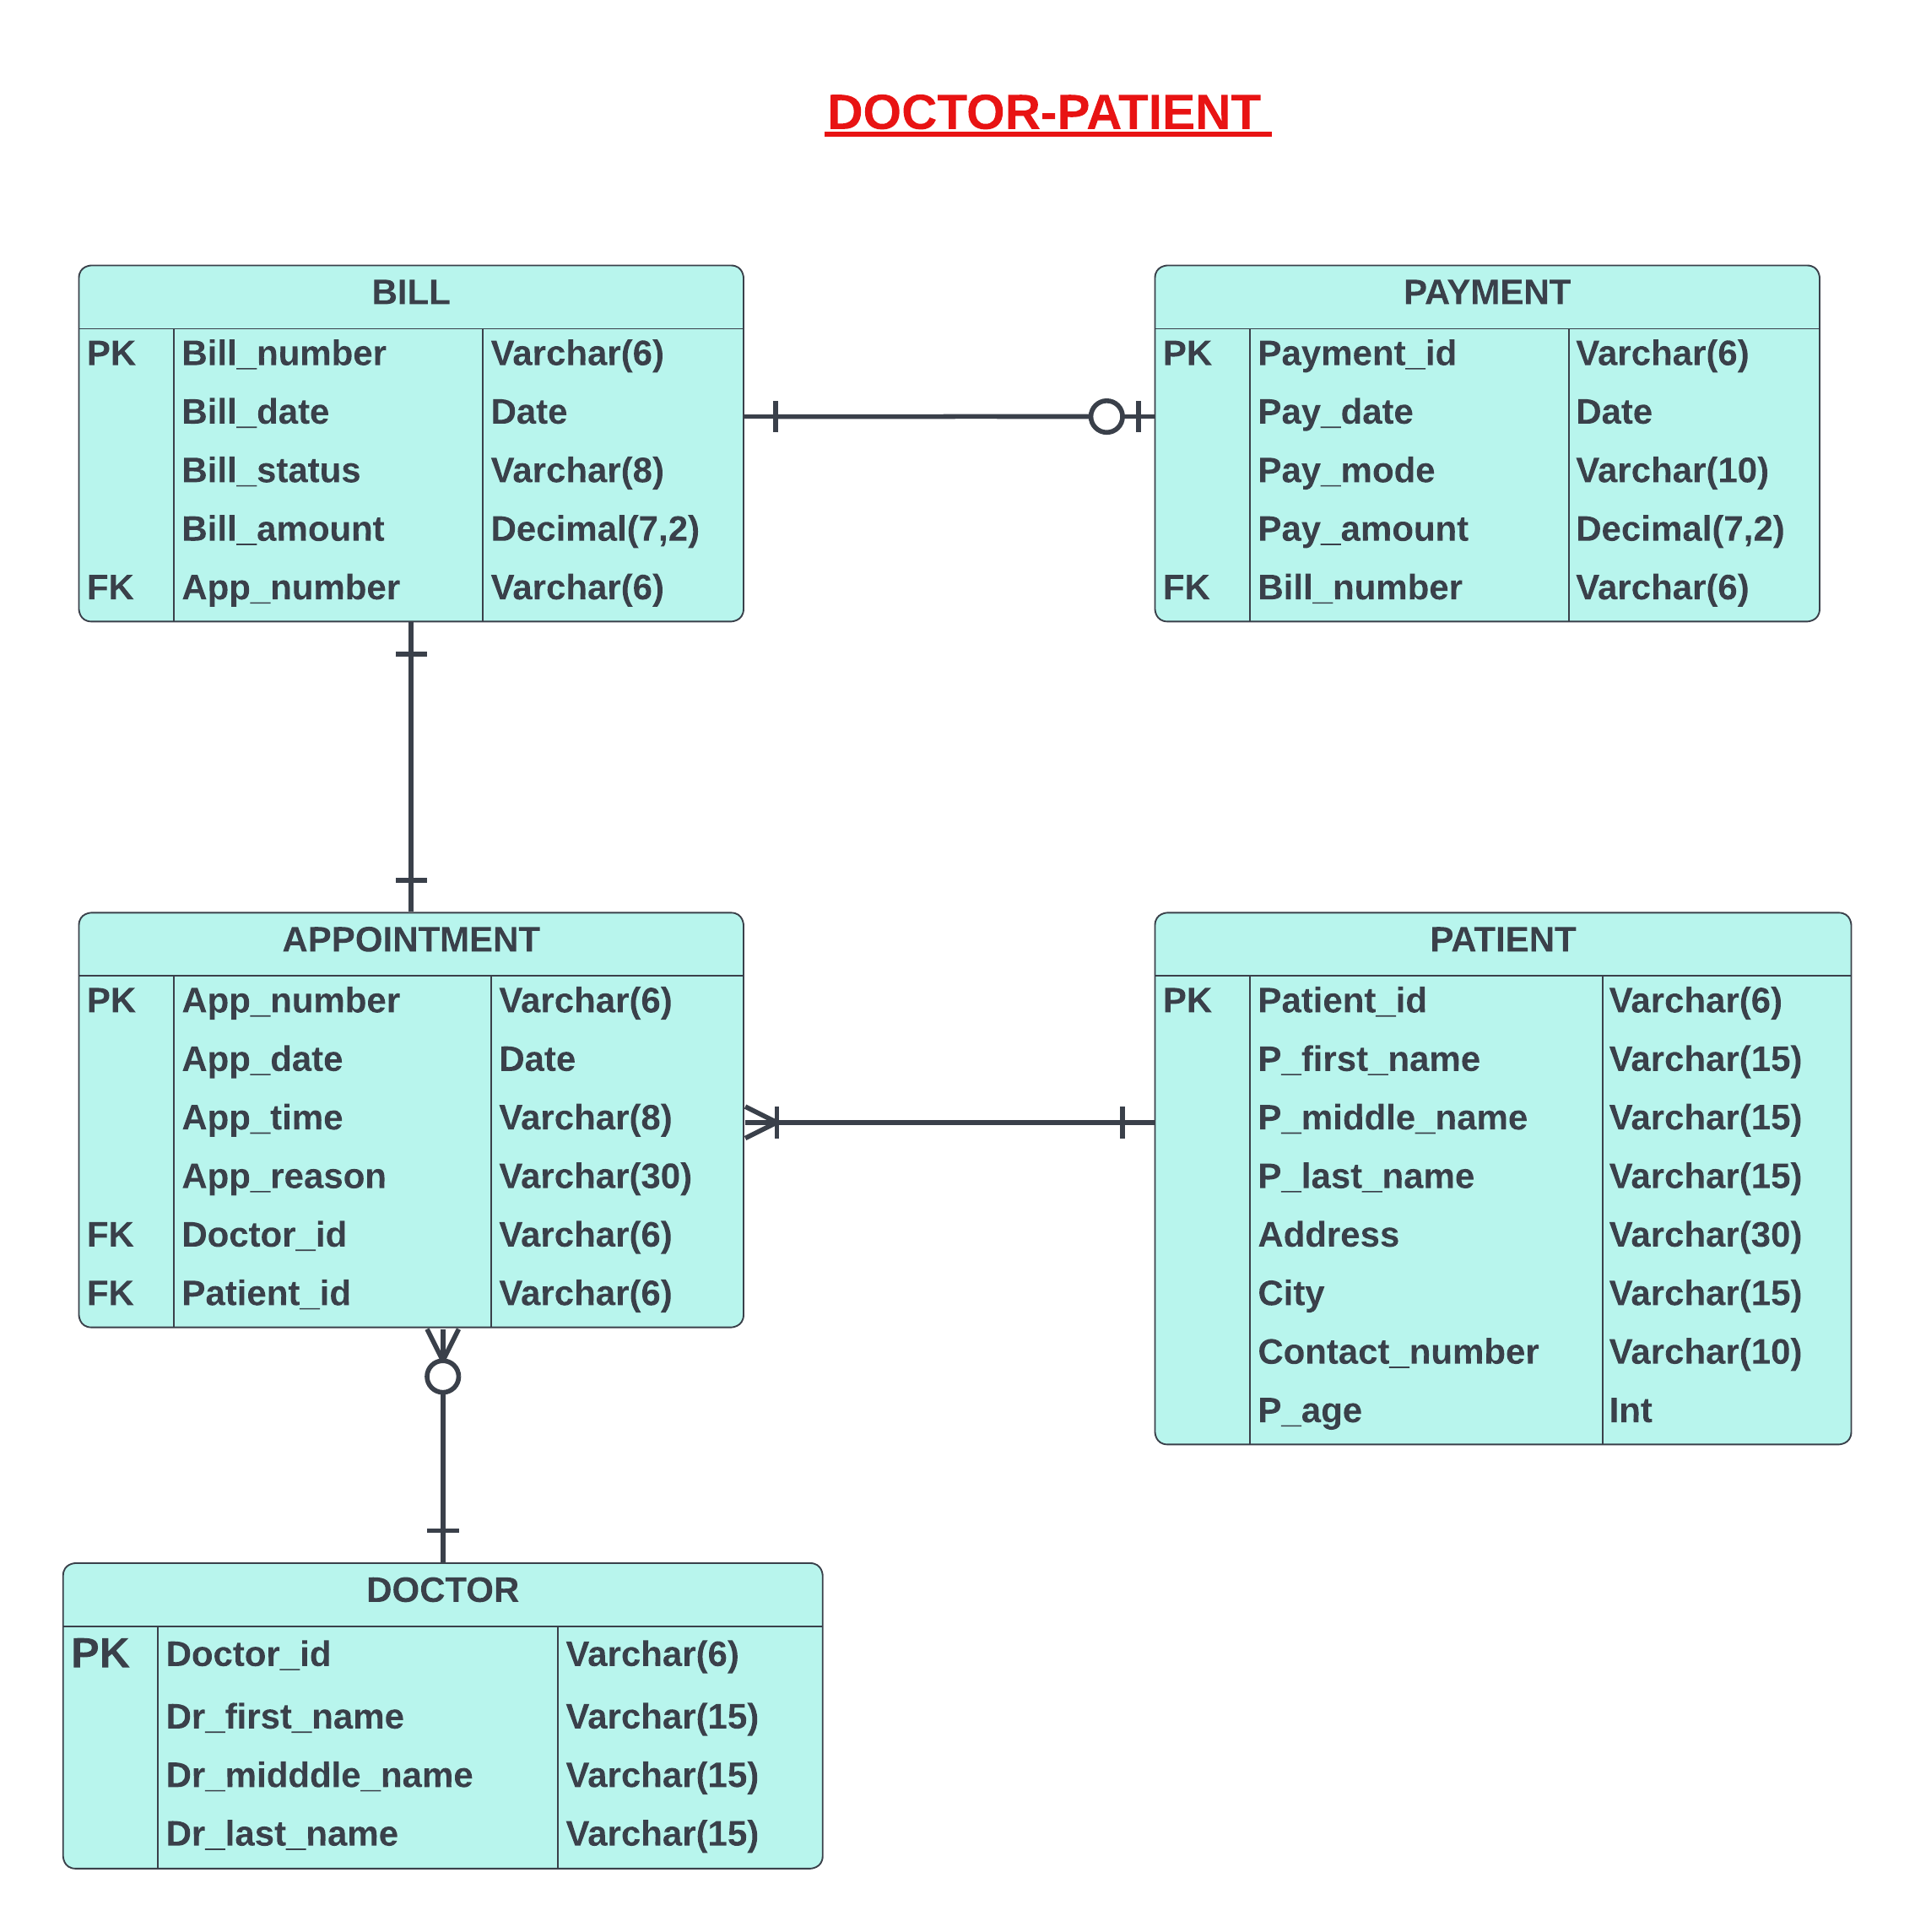

## Q12 **Ordered Month**

The shop manager likes to take a list of customers who ordered cakes from 'February' to 'August'. Write a query to display the unique customer name, email id and phone number of all customers.

Sort the results based on the customer name in ascending order.



## Q13 **Seat Count**

Due to the severe spread of an unknown disease, the government has decided to reduce the seating capacity by 25% to control the situation in the year 2000.

Write a query to display the boat id, boat name, boat type and SEAT_COUNT of all the boats that traveled in the year 2000. Give an alias name as 'SEAT_COUNT'. Round off the seat count to two decimal places.

Sort the results based on the boat name in descending order.

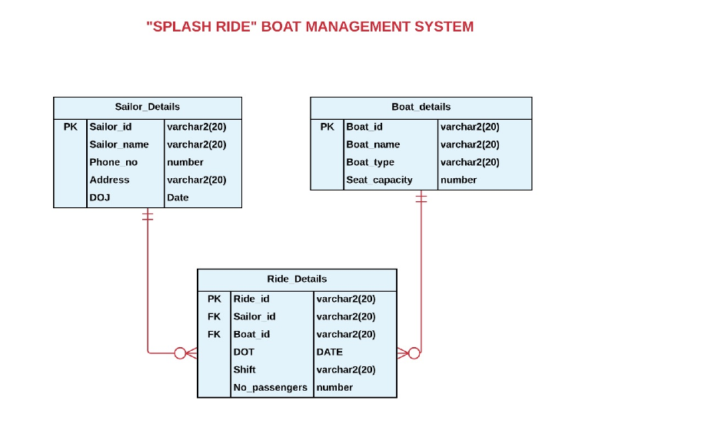

## Q14 **Movie Details**

Write a query to display the Id, name and show time of all the 'Tamil' movies that are not 'A' certified.

Sort results based on the screening id in descending order.

(Note: Language may be 'Tamil, 'tamil', 'TAMIL')



## Q15 **Bill Payment**

Write a query to display the patient id, first name, city and age of the patient who has not made payments.

Sort the results based on the age of the patient in ascending order.

## Q16 **Policy Enrolled Customers With Gmail User**

Write a query to display the customer id, customer name, policy id, total amount and number of years of all the customers who are enrolled in the policies using 'gmail' as their email.

Sort the results based on the enrollment id in descending order.

(Note: Data is case-sensitive.)

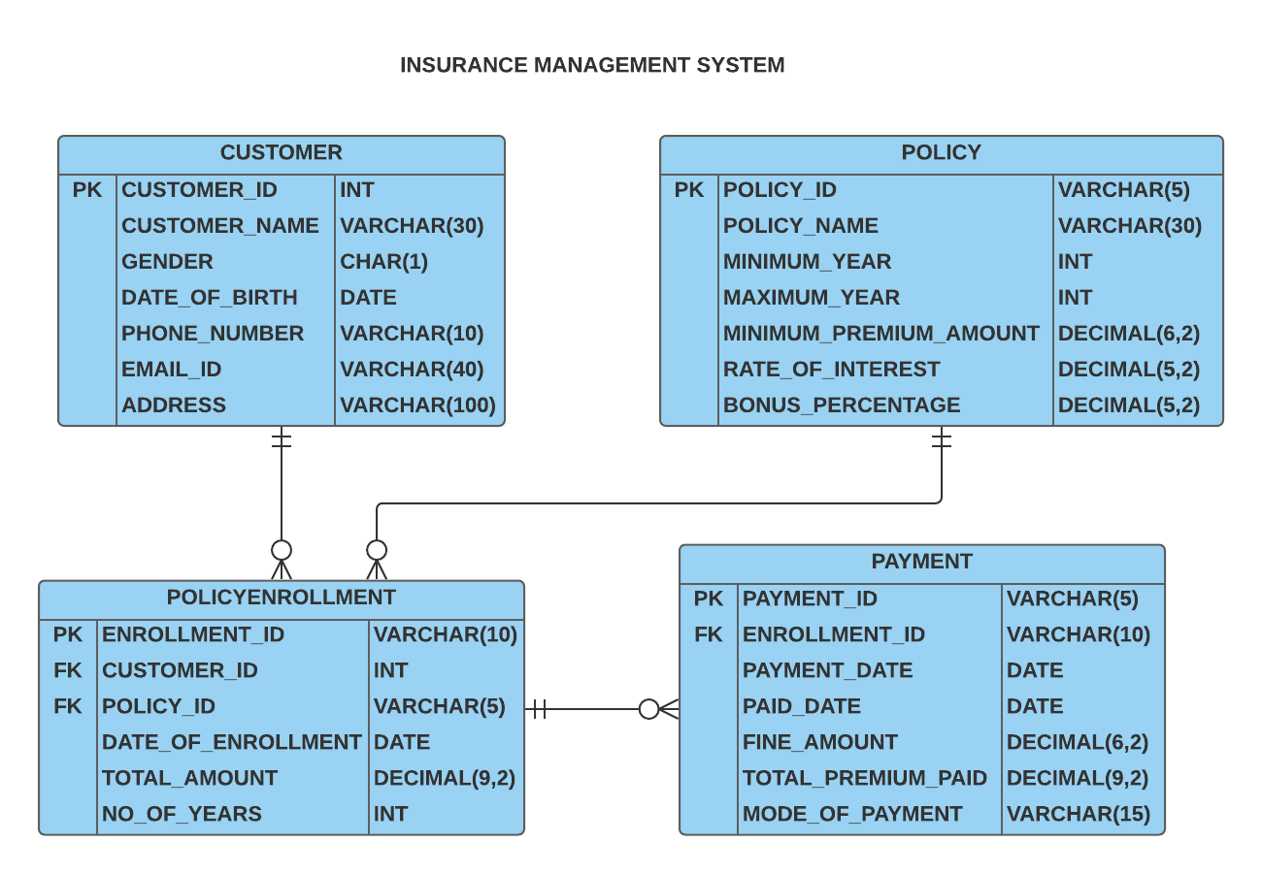

## Q17 **Male Policy Enrollments**

Write a query to display the customer id, customer name and policy id of all the policies enrolled by male customers.

Sort the results based on the enrollment id in descending order.

(Hint: Gender contains 'M' or 'F'.)

(Note: Data is case-sensitive.)



## Q18 **Most Number Of Years**

Write a query to display the policy id and name of the policies that were enrolled for the most number of years.

Sort the records based on the policy name in ascending order.

(**Hint:** Use NO_OF_YEARS to calculate the most number of years.)



## Q19 **Customer And Booking Details**

Write a query to display the name and total amount paid by all the customers who booked tickets in the year 2018.

Sort the results based on the booking id in descending order.



## Q20 **Patient from Same City**

Write a query to display the first name and city of the patient who hails from the same city.

Sort the results based on the city in ascending order and first name of the patient in ascending order.



## Q21 **Recent Subscriber**

Write a query to display the name of the subscriber who most recently recharged their phone number.

If there is more than 1 record, sort the records based on the customer name in descending order.

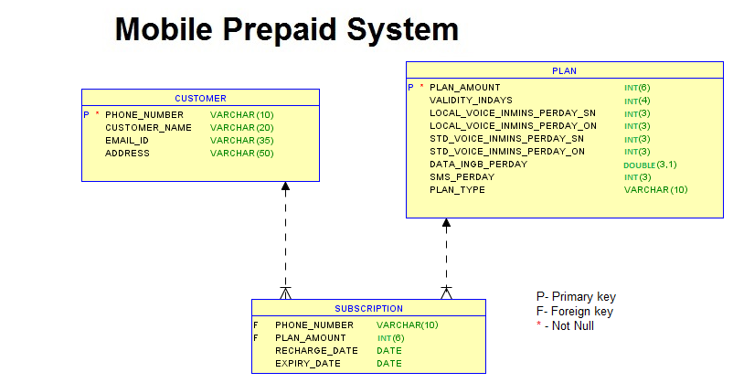

## Q22 **Customer details based on gender**

Please follow instructions given below.  
  
Write a query which will display the customer id, customer name, date of birth, Marital Status, Gender, Guardian name, contact no and email id of the customers whose gender is male 'M' and marital status is MARRIED.

Display the records sorted in ascending order based on customer id.

(Note: Data is case sensitive)

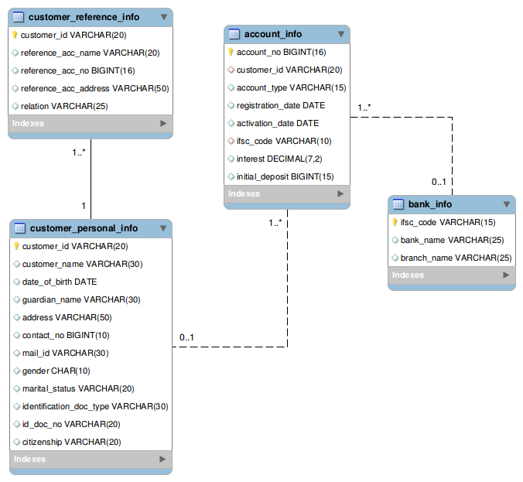

## Q23 **Passcode generation**

Please follow instructions given below.  
  
Write a query which will display customer id, account number and passcode.  
 Hint: To generate passcode, join the last three digits of customer id and last four digit of account number. Example C-001 1234567898765432 0015432 Use "PASSCODE" as alias name for displaying the passcode. Display the records sorted in ascending order based on customer id.

(Note: Data is case sensitive)

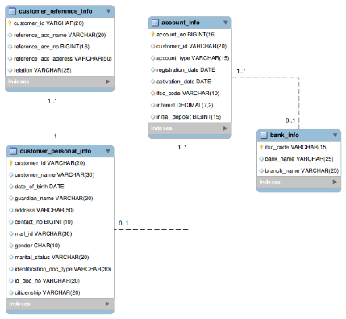

## Q24 **Customer details based on name**

Please follow instructions given below.  
  
Write a query which will display customer id, customer name, date of birth, guardian name of the customers whose name starts with 'J'.

Display the records sorted in ascending order based on customer id.

(Note: Data is case sensitive)

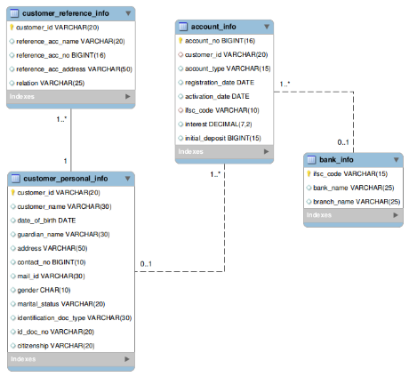

## Q25 **Customer details based on name starting with 'J'**

|  |
| --- |
| Please follow instructions given below.  Write a query which will display customer id, customer name, account number, account type, bank name, ifsc code, initial deposit amount and new interest amount for the customers whose name starts with 'J'.  Hint: Formula for calculating 'new interest amount' is if customers account type is 'SAVINGS' then add 10 % on current interest amount to interest amount else display the current interest amount. Round the new interest amount to 2 decimals. Use 'NEW_INTEREST' as alias name for displaying the new interest amount. Example, Assume Jack has savings account and his current interest amount is 10.00, then the new interest amount is 11.00 i.e (10 + (10 * 10/100)). Display the records sorted in ascending order based on customer id. |



## Q26 **Customer details based on tax**

Please follow instructions given below.  
  
 Write query to display the customer id, customer name, account no, initial deposit, tax percentage as calculated below.  
  
Hint: If initial deposit = 0 then tax is '0%' If initial deposit <= 10000 then tax is '3%' If initial deposit > 10000 and initial deposit < 20000 then tax is '5%' If initial deposit >= 20000 and initial deposit<=30000 then tax is '7%' If initial deposit > 30000 then tax is '10%' Use the alias name 'taxPercentage'. Display the records sorted in ascending order based on customer id.



## Q27 **Customer account details**

|  |
| --- |
| Please follow instructions given below.  Write a query which will display the customer id, account type they hold, their account number and bank name.  Display the records sorted in ascending order based on customer id. |



## Q28 **Customer interest details based on friend reference**

|  |
| --- |
| Please follow instructions given below.  Write a query which will display the customer id, customer name, guardian name, reference account holders name of the customers who are referenced / referred by their 'FRIEND'.  Display the records sorted in ascending order based on customer id. |

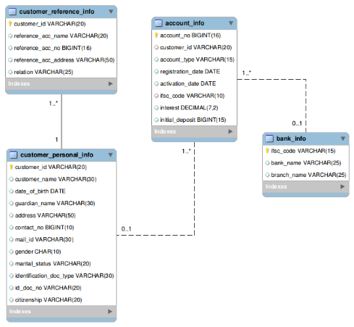

## Q29 **Customer interest details in specified format**

|  |
| --- |
| Please follow instructions given below.  Write a query to display the customer id, account number and interest amount in the below format with INTEREST_AMT as alias name. Sort the result based on the interest in ascending order and then by customer id in ascending order. Example: $5  Hint: Need to prefix $ to interest amount and round the result without decimals. |

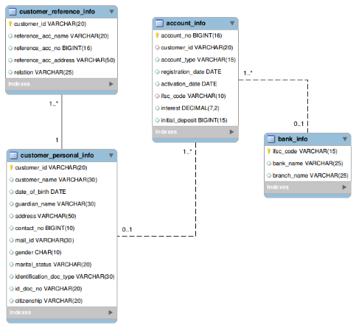

## Q30 **Customer details based on activation date**

Please follow instructions given below.

Write a query which will display the customer id, customer name, account no, account type, activation date, bank name whose account will be activated on '10-APR-2012'.

Display the records sorted in ascending order based on customer id.

## Q31 **Customer details based on interest and deposit amount**

Please follow instructions given below.

Write a query which will display account number, customer id, customer name, bank name, branch name, ifsc code, citizenship, interest and initial deposit amount of all the customers.

Display the records sorted in ascending order based on customer id.



## Q32 **Customer details based on identification document**

Please follow instructions given below.

Write a query which will display customer id, customer name, date of birth, guardian name, contact number, mail id and reference account holder's name of the customers who has submitted the passport as an identification document.

Display the records sorted in ascending order based on customer id.

## Q33 **Customer details who all having account in bank**

Please follow instructions given below.

Write a query which will display the customer id, customer name, account no, account type and bank name where the customers hold the account.

Display the records sorted in ascending order based on customer id.

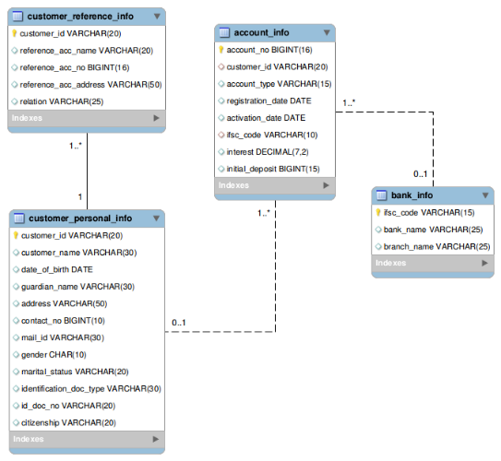

## Q34 **Customer details based on reference string**

Please follow instructions given below.  
  
Write a query which will display the customer id, customer name, gender, marital status along with the unique reference string and sort the records based on customer id in descending order.

Hint: Generate unique reference string as mentioned below: CustomerName_Gender_MaritalStatus Example, C-005 KUMAR M SINGLE KUMAR_M_SINGLE Use "UNIQUE_REF_STRING" as alias name for displaying the unique reference string.

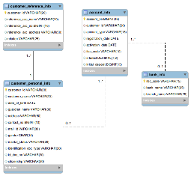

## Q35 **Customer details based on deposit amount range**

Please follow instructions given below.  
Write a query which will display the account number, customer id, registration date, initial deposit amount of the customer whose initial deposit amount is within the range of Rs.15000 to Rs.25000.

Display the records sorted in ascending order based on account number.

(Note: Data is case sensitive)



## Q36 **Customer account details based on account type**

Please follow instructions given below.  
  
Write a query which will display customer id, customer name, guardian name, identification doc type, reference account holders name, account type, ifsc code, bank name and current balance for the customers who has only the 'SAVINGS' account. Hint: Formula for calculating current balance is add the intital deposit amount and interest and display without any decimals. Use 'CURRENT_BALANCE' as alias name.  
(Note: Data is case sensitive)  
 Display the records sorted in ascending order based on customer id

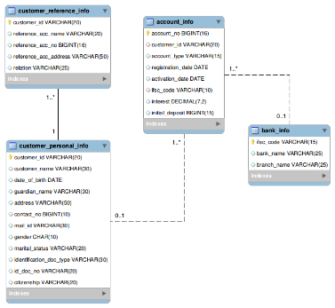

## Q37 **Customer account details based on activation date**

Please follow instructions given below.

Write a query which will display account number, account type, customer id, customer name, date of birth, guardian name, contact no, mail id , gender, reference account holders name, reference account holders account number, registration date, activation date, number of days between the registration date and activation date with alias name "NoofdaysforActivation", bank name, branch name and initial deposit for all the customers.

(Note: Data is case sensitive)  
Display the records sorted in ascending order based on account number



## Q38 **Customer details based on bank**

Please follow instructions given below.  
Write a query which will display the customer id, account type and the account number of HDFC customers who registered between 12-JAN-2012 and 04-APR-2012.

Display the records sorted in ascending order based on customer id.

(Note: Data is case sensitive)

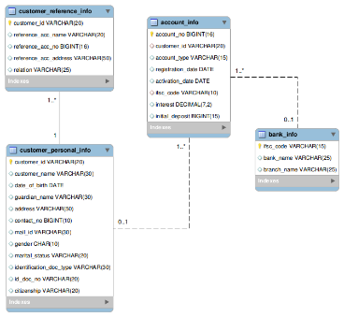

## Q39 **Customer details based on contact details**

Please follow instructions given below.

 Write a query which will display the customer id, customer name and contact number with ISD code of all customers in below mentioned format. Sort the result based on the customer id in descending order. Format for contact number is : "+91-3digits-3digits-4digits" Example: +91-924-234-2312 Use "CONTACT_ISD" as alias name.

(Note: Data is case sensitive)

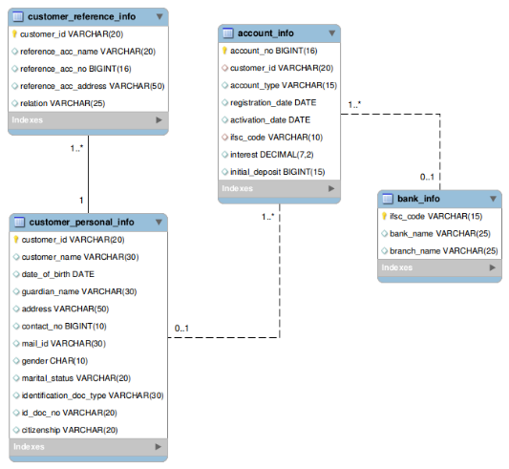

## Q40 **Customer details based on reference name**

Please follow instructions given below.  
 Write a query to display the customer id, customer name, date of birth, guardian name, contact number, mail id, reference name who has been referenced by 'RAGHUL'.  
  
Display the records sorted in ascending order based on customer id. (Note: Data is case sensitive)



## Q41 **Customer details based on city**

Please follow instructions given below.  
Write a query to display the customer id, customer name, account no, bank name, contact no and mail id of the customers who are from BANGALORE.

Display the records sorted in ascending order based on customer id.

(Note: Data is case sensitive)



## Q42 **Customer details based on initial deposit**

Please follow instructions given below.  
  
Write a query which will display the customer id, customer name, account number, account type, interest, initial deposit; check the initial deposit, if initial deposit is 20000 then display 'high', if initial deposit is 16000 display 'moderate', if initial deposit is 10000 display 'average', if initial deposit is 5000 display 'low', if initial deposit is 0 display 'very low' otherwise display 'invalid' and sort by interest in descending order and then by customer id in descending order.  
  
Hint: Name the column as "Deposit_Status" (alias). Strictly follow the lower case for strings in this query. (Note: Data is case sensitive)



## Q43 **Customer details who getting maximum interest rate**

Please follow instructions given below.

 Write a query to display the customer id, customer name, account number, account type, interest, bank name and initial deposit amount of the customers who are getting maximum interest rate. In case of multiple records, display the records sorted in ascending order based on customer id.

(Note: Data is case sensitive)



## Q44 **Customer account details based on deposited amount**

Please follow instructions given below.

Write a query to display the customer id, customer name, account number, account type, initial deposit, interest who have deposited maximum amount in the bank. In case of multiple records,display the records sorted in ascending order based on customer id.

(Note: Data is case sensitive)



## Q45 **Customer details based on activation date**

Please follow instructions given below.  
  
Write a query which will display customer id, bank name, branch name, ifsc code, registration date, activation date of the customers whose activation date is in the month of march (March 1'st to March 31'st).

 Display the records sorted in ascending order based on customer id.

(Note: Data is case sensitive)



## Q46 **Customer bank details based on interest amount**

Please follow instructions given below.  
  
Write a query which will calculate the interest amount and display the customer id, customer name, account number, account type, initial deposit amount, interest and interest amount.

Hint :Formula for interest amount, calculate: ((interest/100) * initial deposit amt) with column name 'interest_amt' (alias). Display the records sorted in ascending order based on customer id.

(Note: Data is case sensitive)

